**DCIT 208**

**10841867**

**APPIAH DAVID AMOAKO**

**ASSIGNMENT 3**

**QUESTION 1 a**

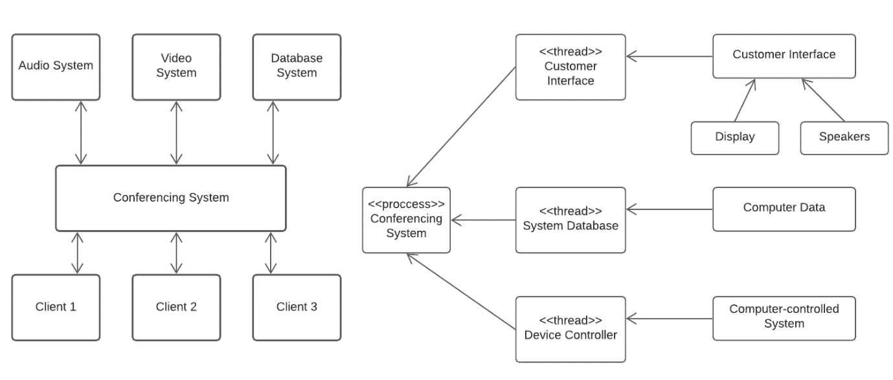

Conceptual View Process View

**QUESTION 1 b**

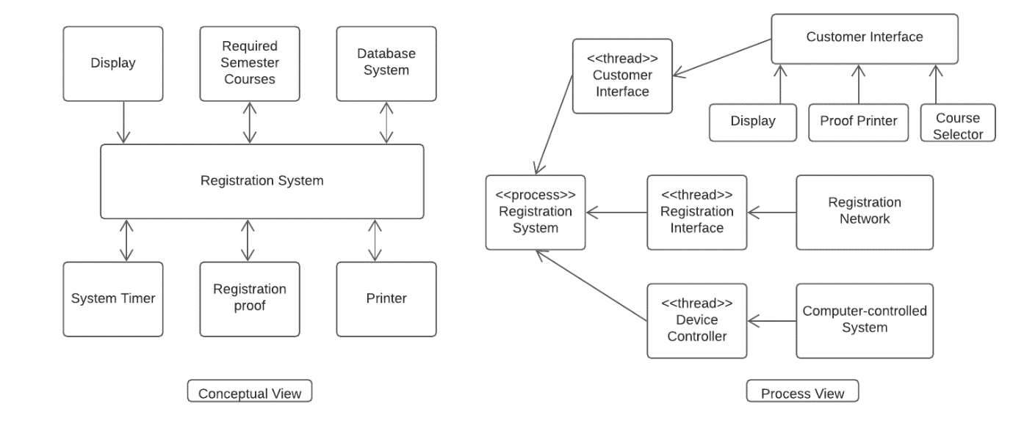

**QUESTION 1 c**

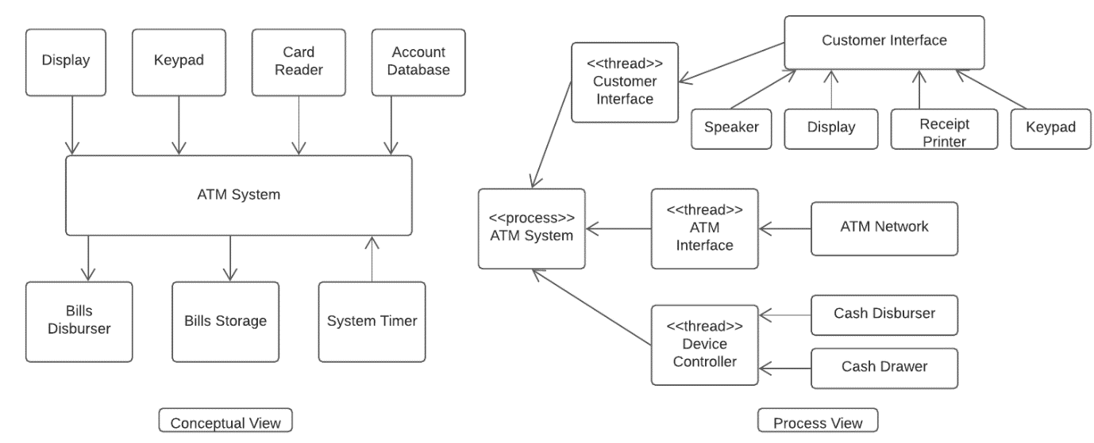

**QUESTION 2**

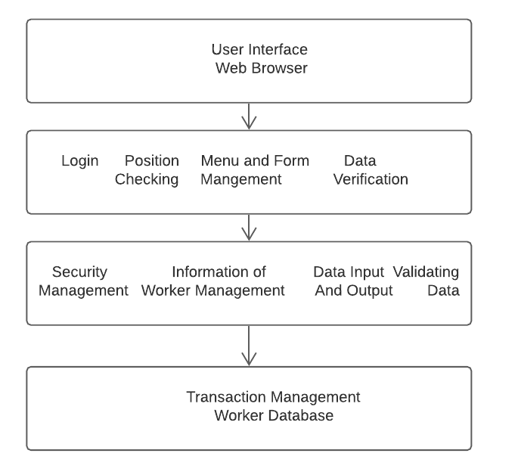

**QUESTION 3**

